PROJECT REPORT

1. INTRODUCTION
1.1 Project Overview
The Food Ordering Behaviour and Consumer Trends project aims to analyze customer ordering patterns using Tableau. The project transforms raw food ordering data into interactive dashboards that help identify customer preferences, popular cuisines, restaurant performance, peak ordering hours, and spending habits. The insights generated support restaurants and food delivery businesses in making data-driven decisions to improve customer satisfaction and business growth.
1.2 Purpose
The purpose of this project is to analyze food ordering behaviour and consumer trends through interactive data visualization. It helps stakeholders understand customer preferences, optimize restaurant operations, identify market trends, and improve decision-making using Tableau dashboards.

2. IDEATION PHASE
2.1 Problem Statement
Food delivery platforms and restaurants generate large amounts of customer and order data. However, analyzing raw data to identify customer preferences, ordering patterns, and business trends is difficult. This project provides an interactive dashboard that converts raw data into meaningful insights for better decision-making.
2.2 Empathy Map Canvas
Says
- I want quick food delivery.
- I prefer restaurants with good ratings.
- I look for affordable food options.
Thinks
- Which restaurant offers the best quality?
- Is the delivery time accurate?
- Are there any discounts available?
Does
- Searches restaurants.
- Applies filters.
- Places food orders.
- Gives ratings and reviews.
Feels
- Happy with fast delivery.
- Frustrated by delays.
- Satisfied with quality food.
2.3 Brainstorming
- Analyze customer ordering behaviour.
- Identify popular cuisines.
- Find peak ordering hours.
- Compare restaurant performance.
- Build interactive Tableau dashboards.
- Generate business insights using visual analytics.

3. REQUIREMENT ANALYSIS
3.1 Customer Journey Map
Customer opens the food delivery app, searches restaurants, compares ratings and prices, places an order, tracks delivery, receives the food, and provides feedback. This journey helps identify customer pain points and opportunities for service improvement.
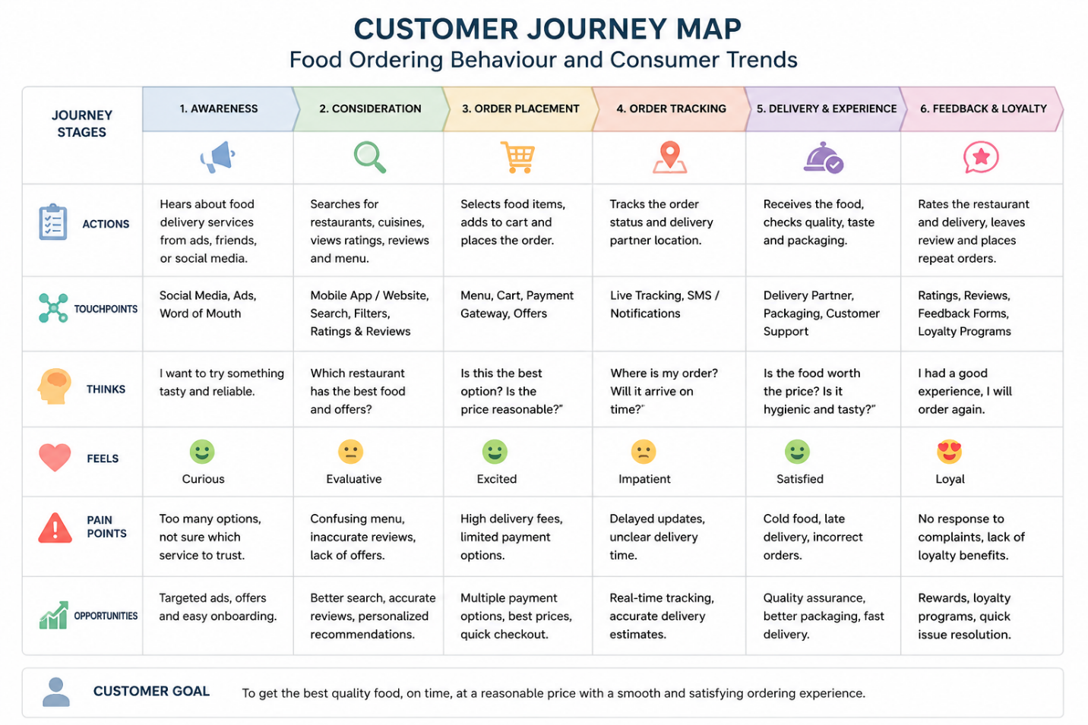
3.2 Solution Requirement
- Interactive Tableau Dashboard
- Data Cleaning and Preparation
- Customer Behaviour Analysis
- Restaurant Performance Analysis
- Trend Analysis
- KPI Dashboard
- Filters and Calculated Fields
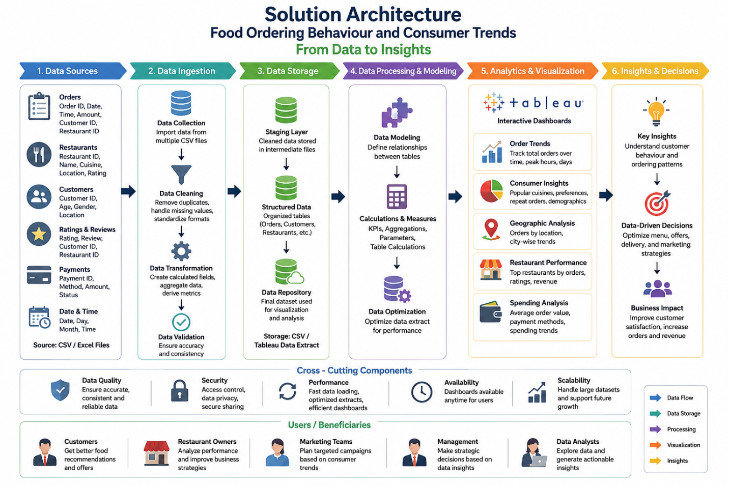

3.3 Data Flow Diagram
CSV Dataset → Data Cleaning → Tableau → Data Analysis → Dashboard → Business Insights
3.4 Technology Stack
- Tableau Desktop/Public
- CSV Dataset
- SQL (Optional)
- Tableau Prep
- Microsoft Excel
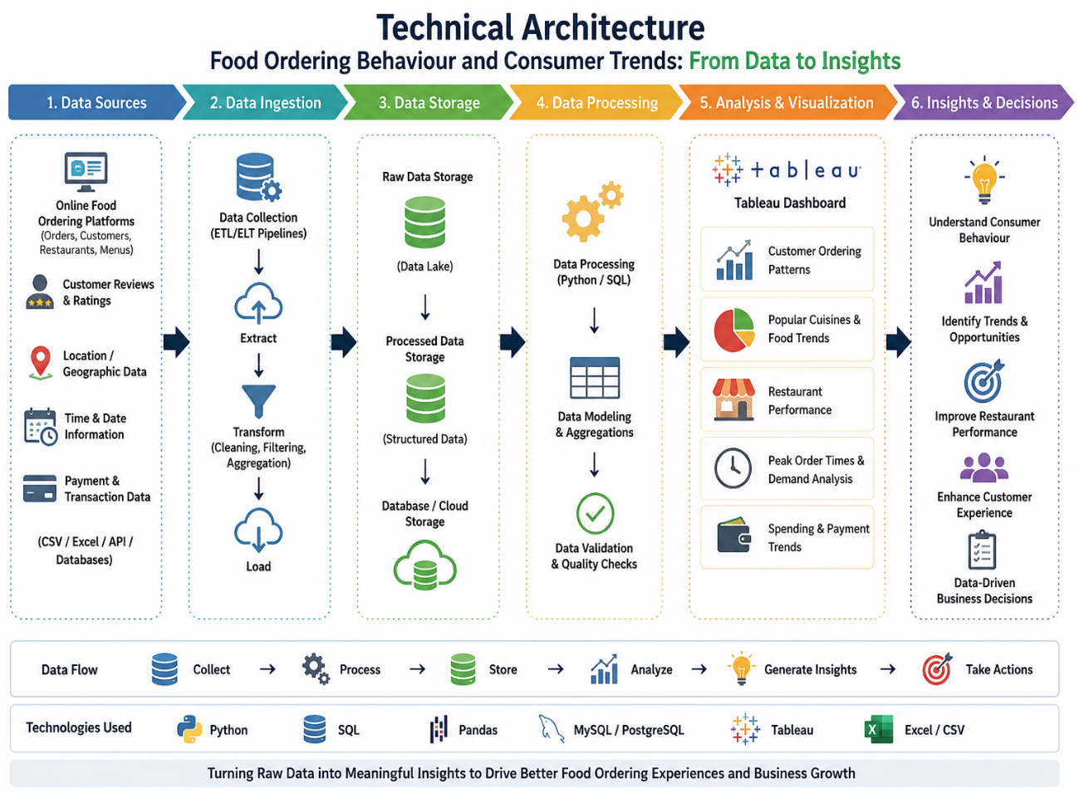

4. PROJECT DESIGN
4.1 Problem Solution Fit
The project converts raw food ordering data into interactive dashboards, enabling businesses to understand customer behaviour, identify trends, improve restaurant performance, and make data-driven decisions.
4.2 Proposed Solution
Develop an interactive Tableau dashboard that visualizes customer ordering behaviour, spending patterns, restaurant performance, customer ratings, and market trends through interactive charts and filters.
4.3 Solution Architecture
Data Sources → Data Preparation → Tableau Visualization → Interactive Dashboard → Business Insights

5. PROJECT PLANNING & SCHEDULING
5.1 Project Planning
The project was executed using Agile methodology with four sprints covering data collection, preprocessing, dashboard development, testing, and documentation.

6. FUNCTIONAL AND PERFORMANCE TESTING
6.1 Performance Testing
- Dataset loaded successfully.
- Dashboard filters responded correctly.
- Charts displayed accurate results.
- Calculated fields generated correct values.

7. RESULTS
7.1 Output Screenshots
Include screenshots of:
- Data Source
- Dashboard
- Filters
- Calculated Fields
- Story

DATA SOURCE
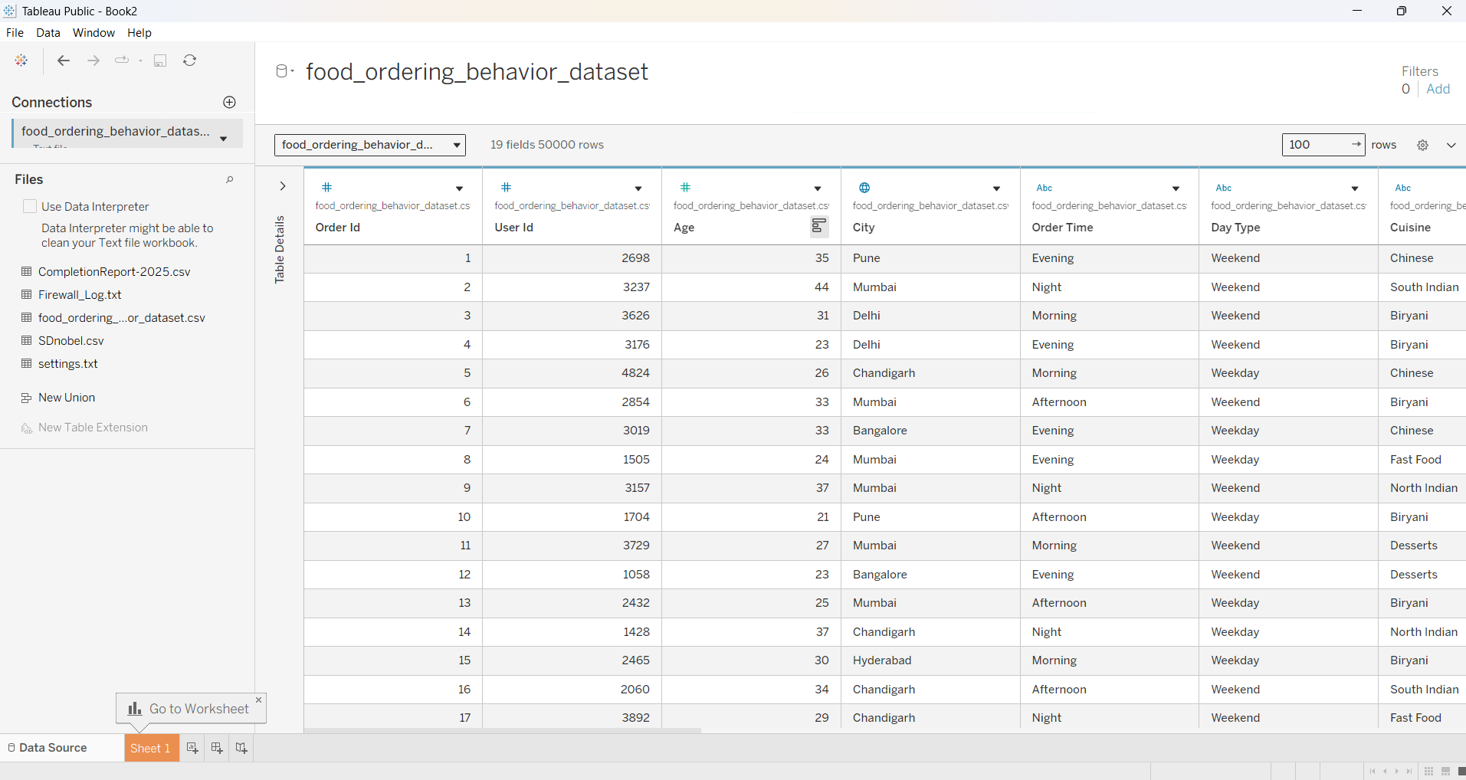

DASHBOARD
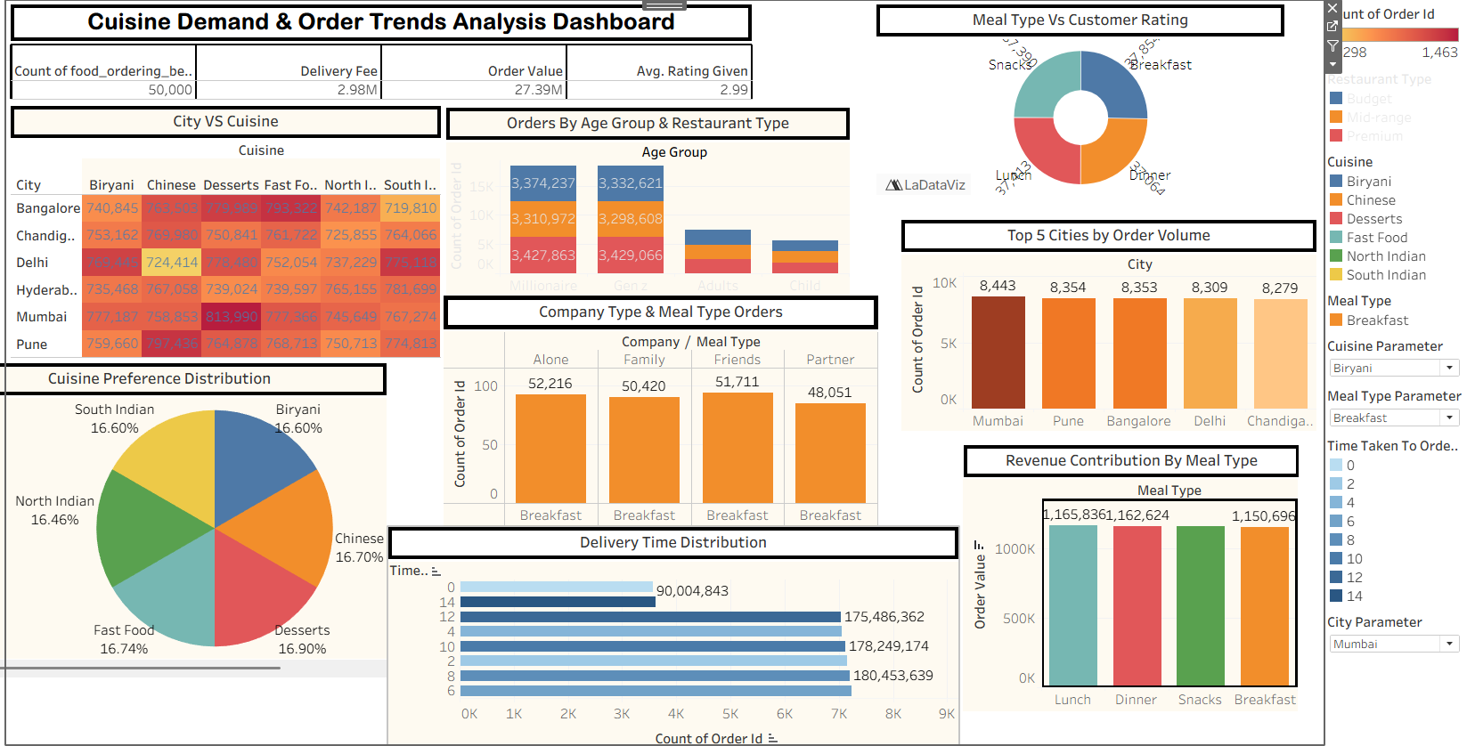

FILTERS
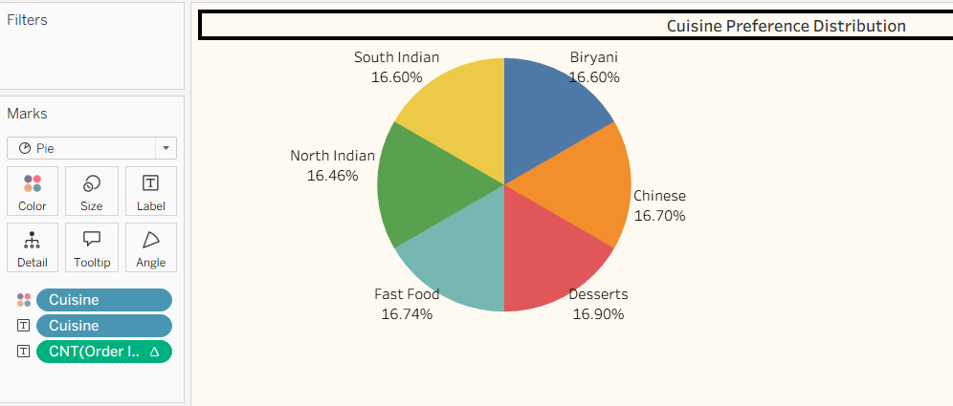

CALCULATED FIELDS
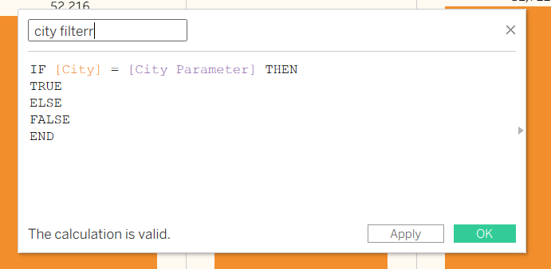

STORY
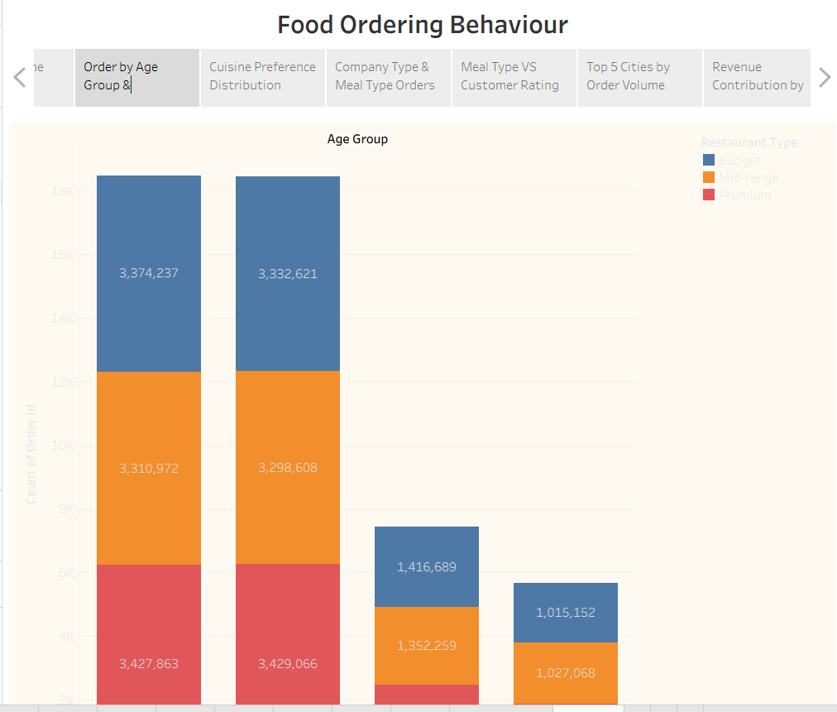

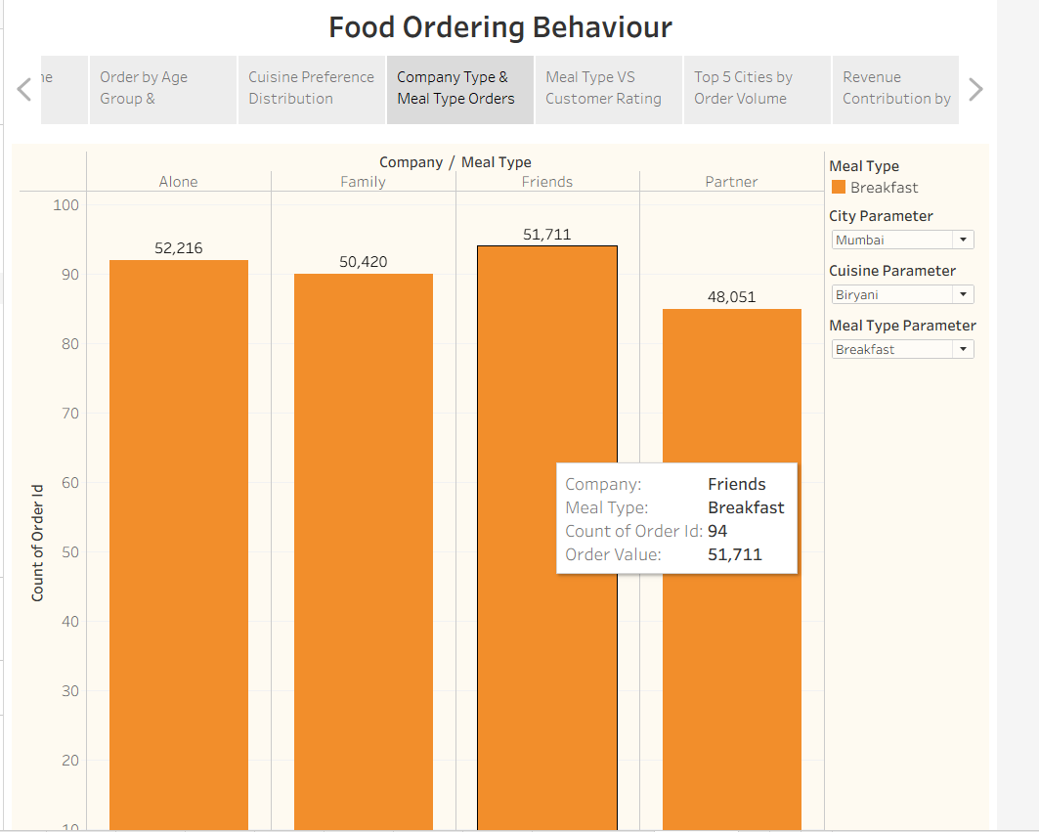

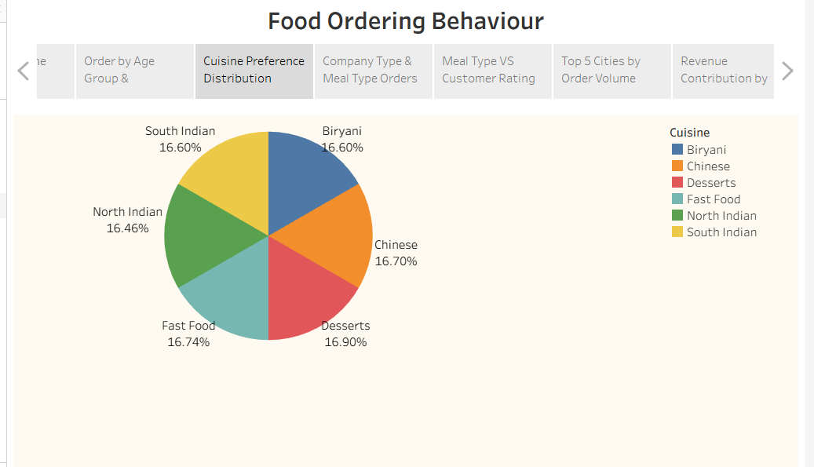

8. ADVANTAGES & DISADVANTAGES
Advantages
- Interactive dashboards.
- Easy to understand.
- Supports data-driven decisions.
- Improves customer satisfaction.
- Identifies business trends quickly.
- Saves reporting time.
Disadvantages
- Depends on data quality.
- Historical data only.
- Real-time analytics not implemented.
- Requires Tableau knowledge for modifications.

9. CONCLUSION
The project successfully analyzes food ordering behaviour and consumer trends using Tableau dashboards. It provides valuable insights into customer preferences, restaurant performance, and market trends, enabling businesses to make informed decisions and improve operational efficiency.

10. FUTURE SCOPE
- Real-time data integration.
- AI-based food recommendation system.
- Predictive analytics using Machine Learning.
- Mobile dashboard support.
- Cloud database integration.
- Customer sentiment analysis using reviews.
- Live business monitoring dashboards.

11. APPENDIX
DATASET LINK
https://drive.google.com/file/d/1__bBUnmTq2-QQMZXj_QqQdSqjwgS8ABS/view
GITHUB LINK

PROJECT DEMO LINK

